- Assignment-1

1.What is SDLC?
- Type of SDLC
1. Requirement Gathering Function Requirement
Not function Requirement
2.Analysis
- Design
- Implementation
5.Testing 6.Maintenance
2.What is software testing?
Software testing is a process used to identify the correctness, completeness , and quality of developed computer software.

3.What is agile methodology?
Agile method is project tern and condition.

4.What is SRS
Software Requirements Specification.

5.What is OOPS
- Object
- Class
- Abstraction
- Encapsulation
5.Inheritance
6.polymorphismm
6.Write basic concepts of oops
Object Oriented Programming.

7.What is object
Object is a real word entity and behavior.

8.What is class?
Class is a blueprint for an object. Class is a collection of object.
9.What is encapsulation
Encapsulation is collect a group of data that’s called encapsulation.

10.What is inheritance
Inheritance means that one class inherits the characteristics of another class.
11.What is polymorphism
Polymorphism is same method or function name to behave differently based on the object.

12.Drow usecase on online book shopping
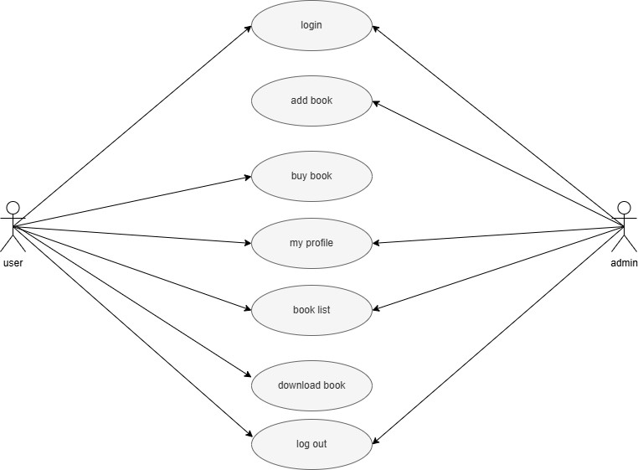

13.Draw usecase on online bill payment system(paytm)
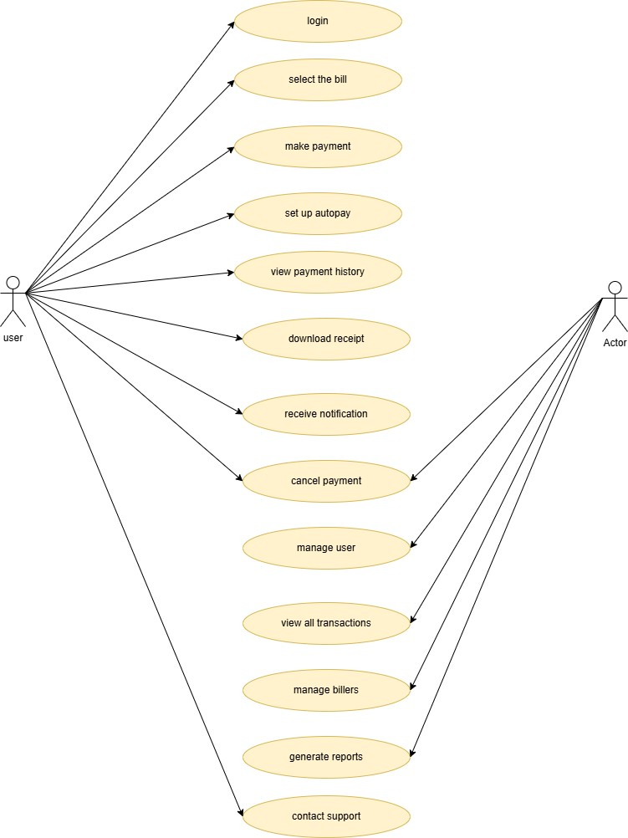

14. write SDLC phases with basic introduction
SDLC
Requirement gathering - customer related
Analysis – model data analysis
Design – model specification and designed
Implementation – data implement and model solution Testing – software testing and solution
Maintenance – defect repair and requirement solution

15.expain phases of the waterfall model
Waterfall model is linear and sequential approach.

16.write phases of spiral model
Spiral model is large and complex, and high-risk projects.

17.write agile manifesto principles
Customer satisfaction and delivery
Customer satisfaction through early and continuous delivery of valuable software.

18.explan working methodology of agile model and also write pros and cons
Agile model – agile promotes flexibility ,team collaboration and continuous customer feedback.
v-model – clear structure , especially useful for small to medium project pros faster delivery customer satisfaction early risk detection

cons
less predictability needs skilled teams

19.draw usecase on online shopping product using COD

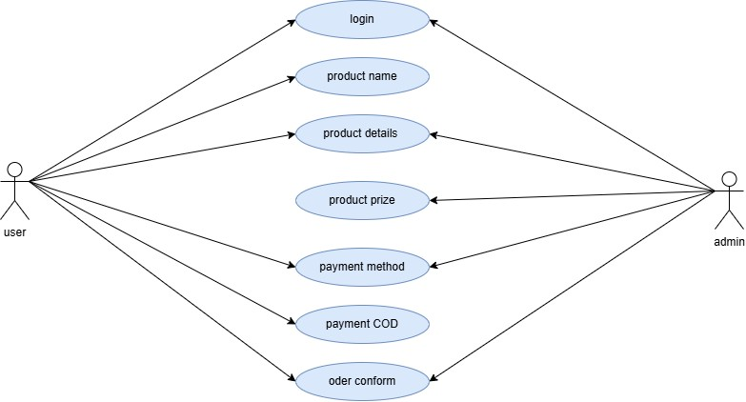

20.draw usecase on online shopping product using payment gateway
